**DAILY ONLINE ACTIVITIES SUMMARY**

|  |  |  |  |  |  |  |  |
| --- | --- | --- | --- | --- | --- | --- | --- |
| **Date:** | 10-06-2020 | | | | **Name:** | Gudugunti Anirudh | |
| **Sem & Sec** | IV - A | | | | **USN:** | 4AL18CS023 | |
| **Online Test Summary** | | | | | | | |
| **Subject** | | Object oriented concepts | | | | | |
| **Max. Marks** | | 30 | | **Score** | | 16 | |
| **Certification Course Summary** | | | | | | | |
| **Course** | **Data structures and algorithms in c++** | | | | | | |
| **Certificate Provider** | | | Udemy | **Duration** | | | **2.5hrs** |
| **Coding Challenges** | | | | | | | |
| **Problem Statement:** 1.Write a Java Program to find the duplicate characters in a string.  —  You | | | | | | | |
| **Status:** Completed | | | | | | | |
| **Uploaded the report in Github** | | | | yes | | | |
| **If yes Repository name** | | | | https://github.com/alvas-education-foundation/anirudh_gudugunti/tree/master/daily_progress | | | |
| **Uploaded the report in slack** | | | | yes | | | |

**Online Test Details**: The online test was from modules 3 and 4, all the questions were objective type questions. All questions were optimal and were easy. The score that I got was 16/30.

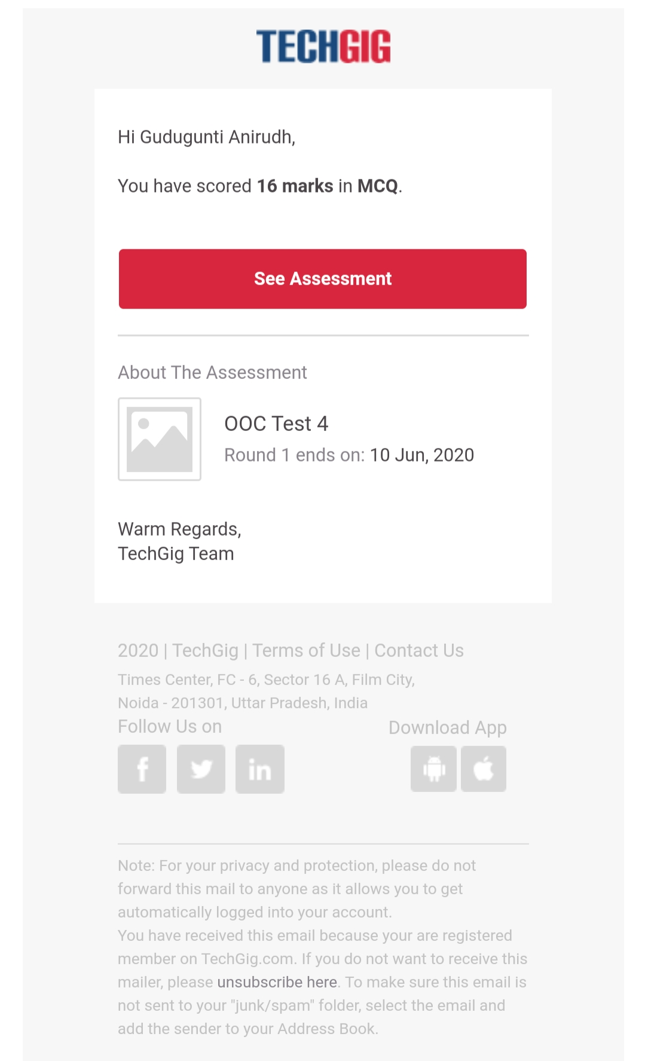

**Snapshot of certification course:**

1. Introduction to stacks.

2. Detailed instructions on stacks with neat diagrams.

3. Some 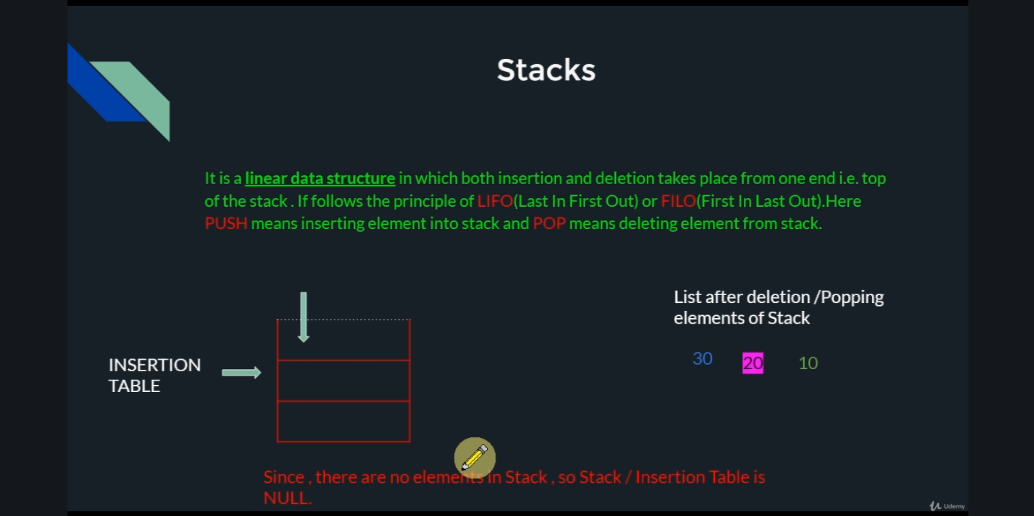worked out examples on stacks.

**Online coding:**

**Problem 1:(using Java)Write a Java Program to find the duplicate characters in a string.**

